Computer Language Diagrams

Command Reference in a Diagram
The principle of command reference is explained in the article Command Reference. This article demonstrates the expression of it in a diagram.

A command reference is displayed in a diagram as a square connected to another square.

The diagram below displays an object, that contains a reference to a command.

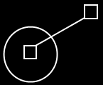

See also: Command Reference

Author & Copyright: Jan-Joost van Zon Date: May 25, 2008 – May 25, 2008 Location: Oosterhout, The Netherlands Status: Finished

